**P7 & P8**

**Introduction**

In these reports, I will have do the ‘ping test’ and the ‘peer to peer test. Screenshots will be provided by each of the criterias for proof that I have completed both of P7 and P8.

**Ping Test**

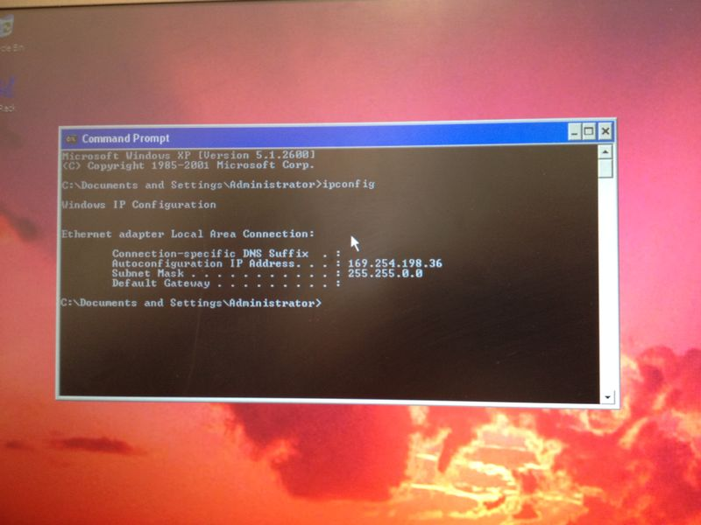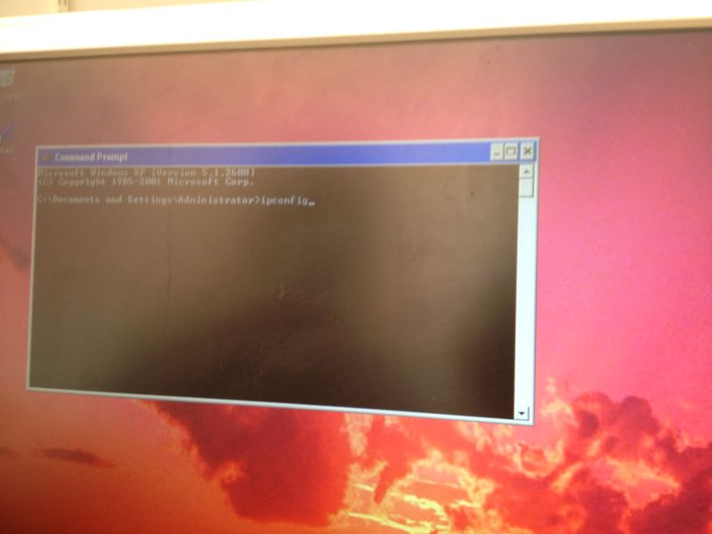

This is the start of the ping test. We got told to straight go on ‘command prompt’ to test if we can communicate through it on the computer. This is the part where we had to find out the IP of the computer. This will enable communication. We typed in ‘ipconfig’ and pressed enter.

This is the part where we found out the IP address. We gave it to other computers to check whether the two computers can communicate with each other.

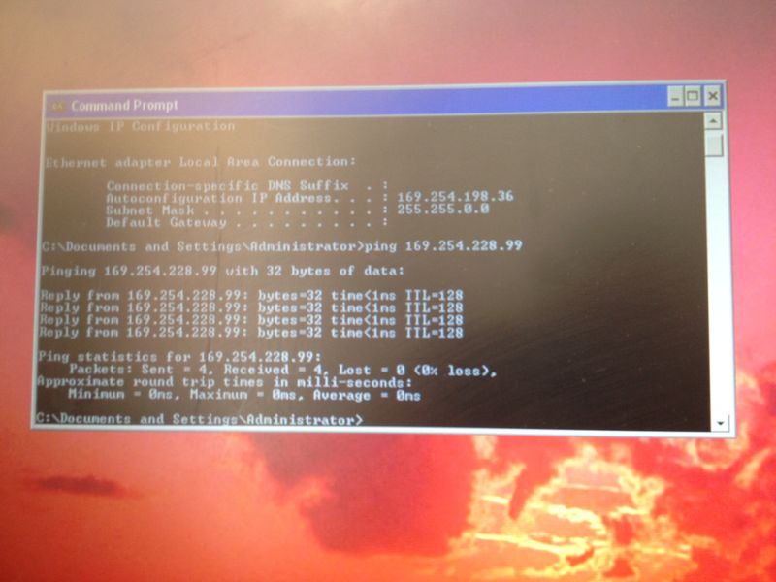

We checked with one computer and they gave their IP address and we gave our IP address to them and pressed enter. ‘O% loss’ means that communication is enabled.

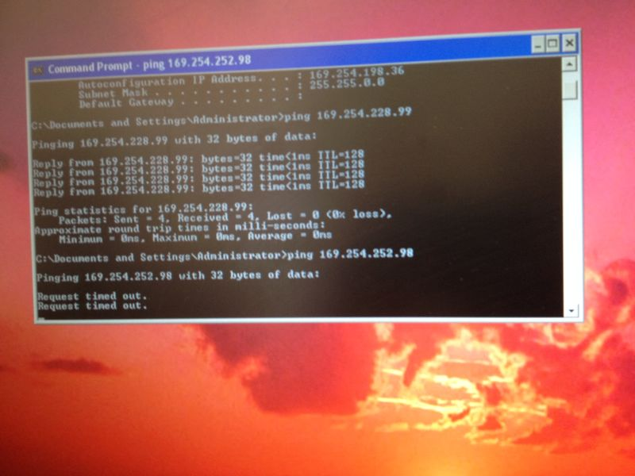

This is another test for another computer. We tested for the computer to see whether communication is enabled. To test it, we need to get the IP address and this is exactly what we did

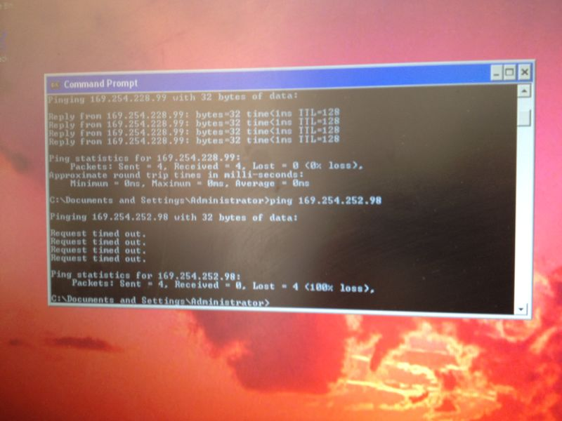

We found out that communication was not enabled. As before, it was completely opposite. ‘100% loss’ means there is no communication.

‘Request timed out’ gives another sign that it is not available.

**Peer to Peer Test**

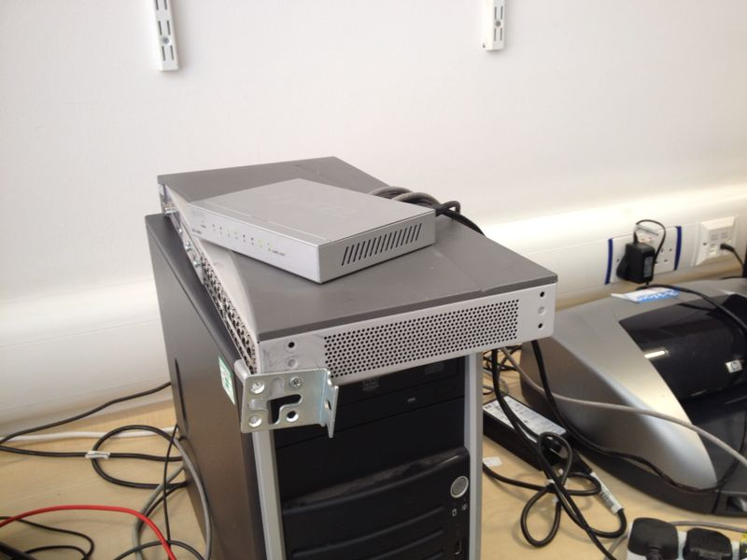

As you can see, they are switches for it to be tested. They are lights and if it is off, peer-to-peer test would not be enabled. This shows that communication has to be with two computers and they have to be linked with the cables to be enabled.

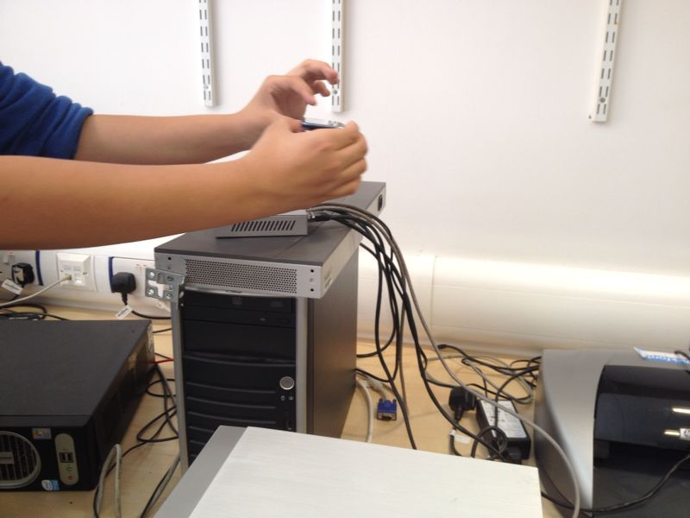

These are the wires showing that it has been connected with the computer.